SOPTIM: Prepared for the next AS4 conversion in the natural gas sector
After the introduction of AS4 in the electricity market communication, SOPTIM prepares for the next challenges in the gas market.

Aachen, 18 June 2024. With the implementation of the AS4 protocol in the power market recently completed, the next major challenge is imminent: the introduction of AS4 in power scheduling and ultimately in the gas market. SOPTIM sees itself as ideally equipped to accompany and support this changeover with its SAGA solution and its extensive experience in technical and specialist market communication.

The introduction of the AS4 protocol last year was a major challenge for the entire industry. The company has proven that it is able to support its customers in an effective and reliable manner even under difficult conditions and that it can deal with regulatory uncertainties.

The positive customer feedback speaks for itself. Jose Perez Lorenzo, Digital Programs Manager at the Spanish energy provider Iberdrola, comments: “Our experience with the service provided by SOPTIM has been flawless. The transition from our old communication systems to SAGA has been as smooth as it could have been even with our extremely tight deadline. SOPTIM has coped our best expectations.”

“We particularly remember the reliable onboarding”, Markus Oetken, Systems Engineer in market communications at RuhrEnergie GmbH, emphasises. “The cooperation with SOPTIM is characterised by the consistently good support during the commissioning phase.”

Preparing for the future of gas market communication

SOPTIM is now intensively preparing to implement the Electricity Schedule Management and to convert to AS4 for communication in the gas market.
The conversion to the AS4 protocol in schedule management will start on 1 October 2024 and will be mandatory from 1 December 2024. In the gas sector, the phased introduction of the AS4 protocol will also start on 1 October 2024 and become mandatory from April 2025.

Judith Kießner, Head of Sales Project Solutions at SOPTIM, says: “Our experience from the switchover in the electricity sector has shown that early planning and preparation are crucial for success. As early as 1 August 2024, the official test phase in the gas sector will begin. We therefore encourage our customers to start preparing in good time. To make the transition as easy and safe as possible, we are here to help them with our proven solution and extensive expertise.”
2.486 characters (including spaces)

Image:
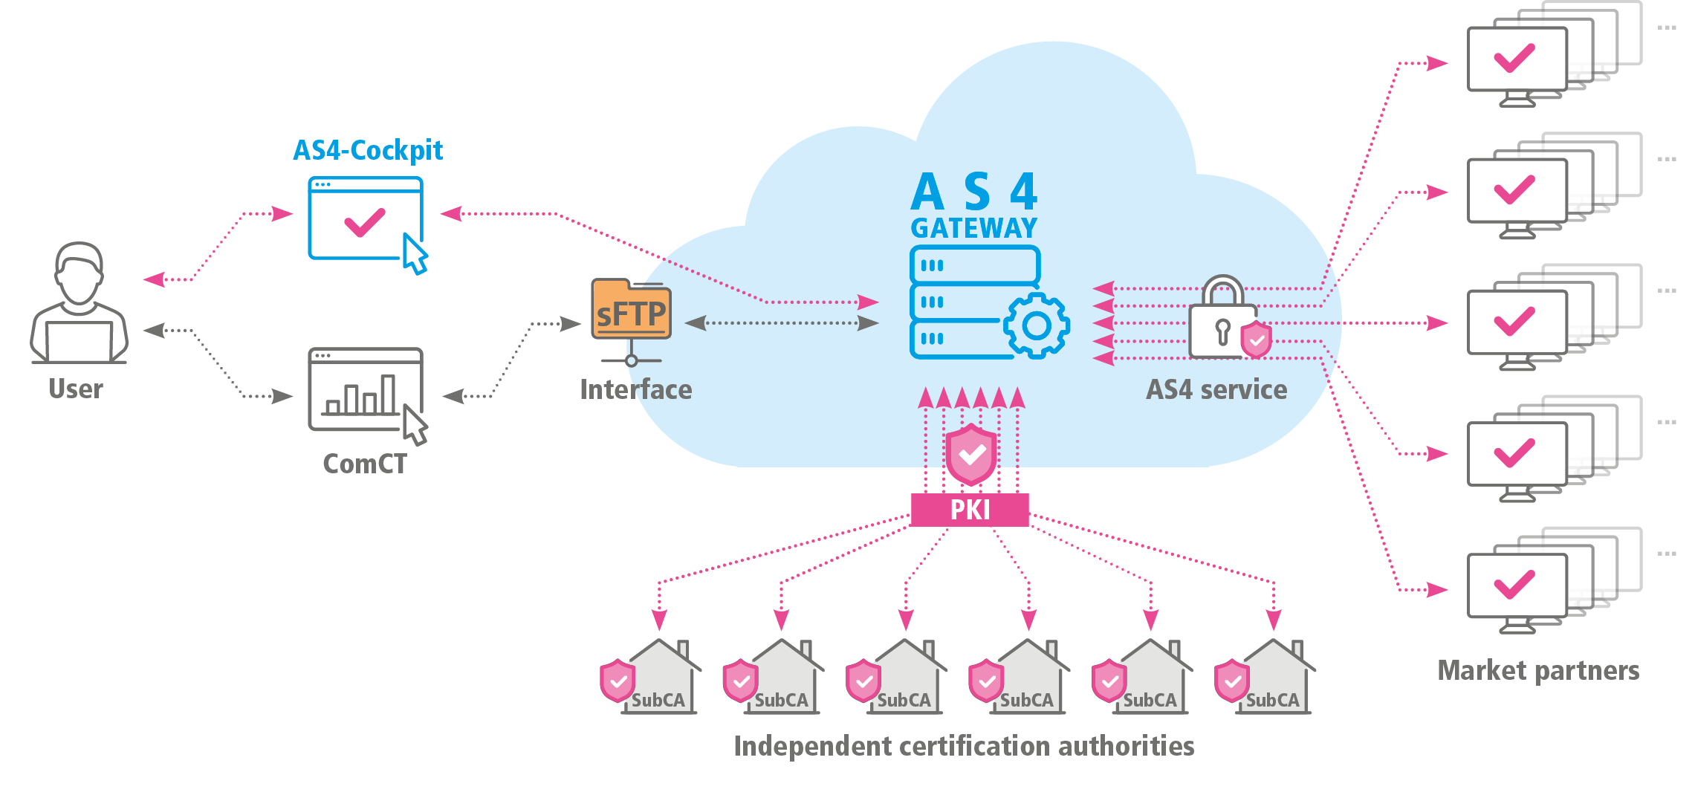
Caption: SOPTIM offers the AS4 solution SAGA in the cloud for all market roles and processes - as a SaaS solution with a simple and scalable usage model.

About SOPTIM
Since over 50 years SOPTIM AG provides IT solutions and services in all areas of the energy sector - from standardised software products to individual project solutions. Special attention is paid to projects in critical infrastructures. With all its solutions, SOPTIM reconciles the energy transition with stable system operation. More than 400 SOPTIMs - in Aachen, Essen and at their mobile workplaces - design, deliver and operate software and remain open to new ideas in a dynamic environment. In order to meet the high demands of the industry, SOPTIM looks at the energy industry from many angles and uses technologies and methods in a targeted manner.

Further information:
SOPTIM AG, Louisa Goblirsch
Im Süsterfeld 5-7, 52072 Aachen
Phone: +49 241 400 23-678
E-Mail: louisa.goblirsch@soptim.de
Web: www.soptim.de

