08 January 2026

Soptim at E-world 2026: More than just software for tomorrow's energy world – new trade fair presentation focuses on dialogue

From dynamic tariffs to AS4 communication: Soptim will be presenting scalable software and a wide range of services for an industry in transition at the trade fair in Essen.

Aachen, Essen. The energy industry is facing major challenges, including digitalisation, new market roles, growing regulation and increasing data volumes, which are making the market more complex and requiring a high degree of flexibility. From 10 to 12 February 2026, Soptim will be exhibiting at E-world energy & water in Hall 1, Stand 1E130. Instead of traditional product presentations, Soptim will be focusing on technical dialogue and personal exchange, talking to market participants about current developments, requirements and prospects.

Further developments in Soptim Elements and stable market processes

Soptim Elements is designed to meet the needs of companies of all sizes and market roles, from established energy suppliers to new entrants from a range of industries. The standardised, modular solutions precisely map and implement specific energy industry processes without lengthy implementation projects. At E-world 2026, Soptim will present further developments including dynamic tariffs, automated MaStR master data reconciliation with optional epilot integration, new gas balancing group management functions, and energy industry data security and processing technologies that can be seamlessly integrated into existing process chains.

'The market has moved away from monolithic systems and now demands agile solutions that can support regulatory changes immediately,' says Frank Bremen, Head of Sales Product Solutions.

Solutions for critical infrastructure

As a well-established provider of solutions for critical infrastructures, Soptim has a long-standing partnership with European transmission system operators and RCCs (Regional Coordination Centres). Its focus includes control systems and control system-related applications, schedule management, redispatch, switch-off planning, control energy and complex billing.

In addition, renowned trading houses and service providers also value Soptim's expertise for fail-safe 24/7 operation in critical short-term trading processes – including technical market communication via AS4.

At E-world 2026, Soptim will provide a forum for personal exchange with all market participants on current technical trends and upcoming technical challenges. Visitors will gain insights into specific use cases based on selected standard solutions for schedule management (NomT), short-term trading (iTrade) and AS4 market communication (SAGA).

'Soptim solutions have proven themselves in the most demanding environments. However, our long-standing success is based less on specific technologies or methods and more on partnership and trust-based cooperation with our customers,' adds Judith Kießner, Head of Sales Project Solutions.

Comprehensive product portfolio through cooperation with specialised subsidiaries

In 2026, Soptim is positioning itself more strongly than ever as a strategic partner along the energy industry value chain. Soptim, together with its subsidiaries, is strategically expanding its portfolio. enprout specialises in operational and economic processes as part of digitised business process outsourcing (BPO) services, esterion provides AI-based forecasts, load profile analyses and price calculations, and sbc assists its customers with smart metering, digitisation, grid integration and the heat transition, as well as with innovation and organisational development processes, among other things.

Meet us at E-world

Visitors are cordially invited to visit Soptim at E-world 2026 in Hall 1, Stand 1E130. The company will be presenting itself there with a newly designed exhibition stand that offers space for personal discussions. Further information and the opportunity to make an appointment can be found at www.soptim.de/e-world.

4,246 characters (including spaces)

Image:
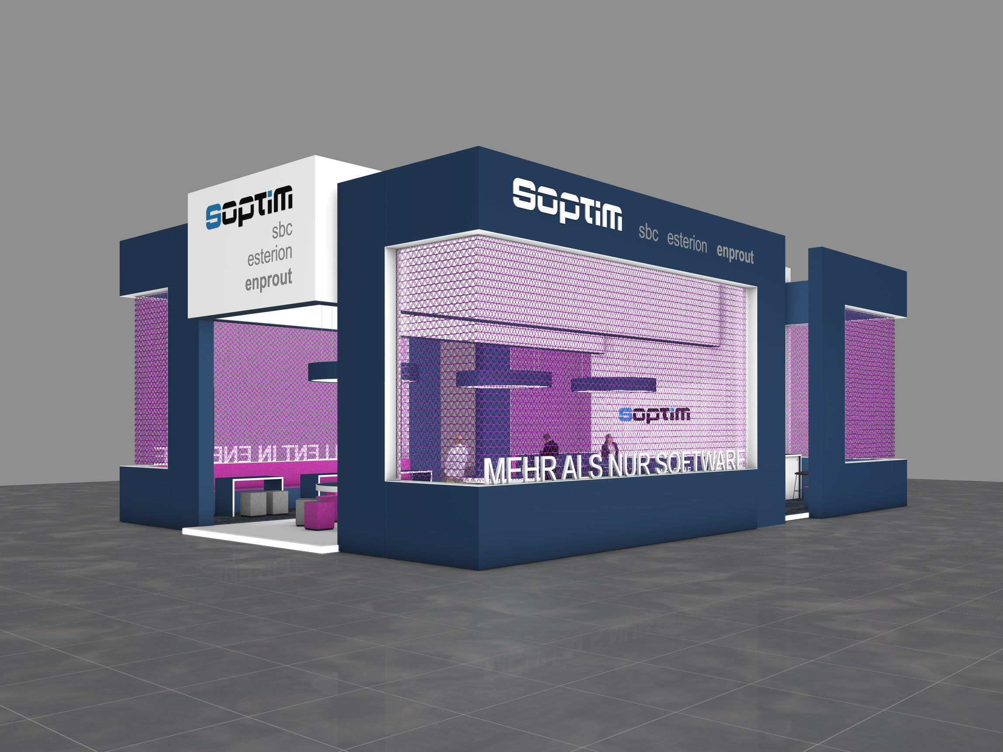

The new Soptim exhibition stand offers space for personal discussions: Stand 1E130 in Hall 1.

About Soptim AG

For over 50 years, we have specialised in the energy industry. Our core business is the integration of technology and energy in critical infrastructures. We specialise in developing and operating software that efficiently supports the energy industry in its various market roles. We use state-of-the-art technologies and cloud solutions as our tools. Our comprehensive portfolio includes project solutions and services for network operators, balancing group managers and suppliers. In addition, we offer products on our Soptim Elements solution platform, which cover all the needs of market players with suitable standard products. It is clear that over 400 Soptim employees are passionate about their work. In Aachen, in Essen, at their mobile workstations or on site.
www.soptim.de/en

Further information:
Soptim AG, Louisa Goblirsch
Im Süsterfeld 5-7, 52072 Aachen
Tel.: +49 241 400 23-678
E-Mail: louisa.goblirsch@soptim.de
Web: www.soptim.de

